Machine learning tutorial: Create your first data science experiment in Azure Machine Learning Studio

This machine learning tutorial walks you through an easy data science experiment. We'll create a linear regression model that predicts the price of an automobile based on different variables such as make and technical specifications. To do this, we'll use Azure Machine Learning Studio to develop and iterate on a simple predictive analytics experiment.

Predictive analytics is a kind of data science that uses current data to predict future outcomes. For a very simple example of predictive analytics, watch Data Science for Beginners video 4: [Predict an answer with a simple model](https://azure.microsoft.com/en-in/documentation/articles/machine-learning-data-science-for-beginners-predict-an-answer-with-a-simple-model/) (runtime: 7:42).

##### **Try Azure Machine Learning for free**

No credit card or Azure subscription needed. [**Get started now >**](https://studio.azureml.net/?selectAccess=true&o=2)

## **How does Machine Learning Studio help?**

Machine Learning Studio makes it easy to set up an experiment using drag-and-drop modules preprogrammed with predictive modeling techniques. To run your experiment and predict an answer, you'll use Machine Learning Studio to create a model, train the model, and score and test the model.

Enter Machine Learning Studio: [https://studio.azureml.net](https://studio.azureml.net/). If you’ve signed into Machine Learning Studio before, click **Sign in here**. Otherwise, click **Sign Up** and choose between free and paid options.

For more general information about Machine Learning Studio, see [What is Machine Learning Studio?](https://azure.microsoft.com/en-in/documentation/articles/machine-learning-what-is-ml-studio/)

## **Five steps to create an experiment**

In this machine learning tutorial, you'll follow five basic steps to build an experiment in Machine Learning Studio in order to create, train, and score your model:

* Create a model
  + [Step 1: Get data](https://azure.microsoft.com/en-in/documentation/articles/machine-learning-create-experiment/#step-1-get-data)
  + [Step 2: Preprocess data](https://azure.microsoft.com/en-in/documentation/articles/machine-learning-create-experiment/#step-2-preprocess-data)
  + [Step 3: Define features](https://azure.microsoft.com/en-in/documentation/articles/machine-learning-create-experiment/#step-3-define-features)
* Train the model
  + [Step 4: Choose and apply a learning algorithm](https://azure.microsoft.com/en-in/documentation/articles/machine-learning-create-experiment/#step-4-choose-and-apply-a-learning-algorithm)
* Score and test the model
  + [Step 5: Predict new automobile prices](https://azure.microsoft.com/en-in/documentation/articles/machine-learning-create-experiment/#step-5-predict-new-automobile-prices)

## **Step 1: Get data**

There are a number of sample datasets included with Machine Learning Studio that you can choose from, and you can import data from many sources. For this example, we will use the included sample dataset, **Automobile price data (Raw)**. This dataset includes entries for a number of individual automobiles, including information such as make, model, technical specifications, and price.

1. Start a new experiment by clicking **+NEW** at the bottom of the Machine Learning Studio window, select **EXPERIMENT**, and then select **Blank Experiment**. Select the default experiment name at the top of the canvas and rename it to something meaningful, for example, **Automobile price prediction**.
2. To the left of the experiment canvas is a palette of datasets and modules. Type **automobile** in the Search box at the top of this palette to find the dataset labeled **Automobile price data (Raw)**.

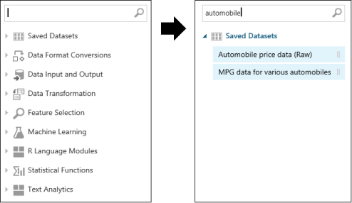

1. Drag the dataset to the experiment canvas.

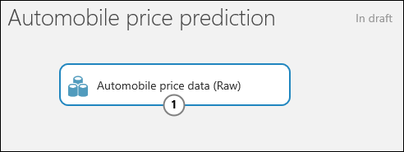

To see what this data looks like, click the output port at the bottom of the automobile dataset, and then select **Visualize**.

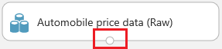

The variables in the dataset appear as columns, and each instance of an automobile appears as a row. The far-right column (column 26 and titled "price") is the target variable we're going to try to predict.

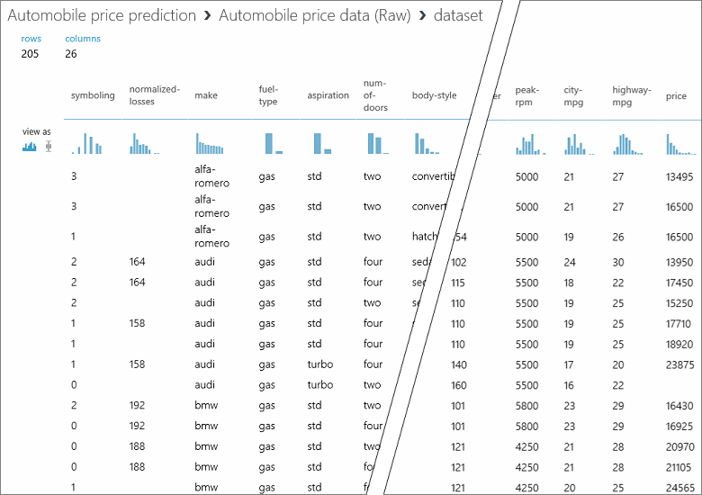

Close the visualization window by clicking the "**x**" in the upper-right corner.

## **Step 2: Preprocess data**

A dataset usually requires some preprocessing before it can be analyzed. You might have noticed the missing values present in the columns of various rows. These missing values need to be cleaned so the model can analyze the data correctly. In our case, we'll remove any rows that have missing values. Also, the **normalized-losses** column has a large proportion of missing values, so we'll exclude that column from the model altogether.

##### **Tip:**

Cleaning the missing values from input data is a prerequisite for using most of the modules.

First we'll remove the **normalized-losses** column, and then we'll remove any row that has missing data.

1. Type **select columns** in the Search box at the top of the module palette to find the [Select Columns in Dataset](https://msdn.microsoft.com/library/azure/1ec722fa-b623-4e26-a44e-a50c6d726223/) module, then drag it to the experiment canvas and connect it to the output port of the **Automobile price data (Raw)** dataset. This module allows us to select which columns of data we want to include or exclude in the model.
2. Select the [Select Columns in Dataset](https://msdn.microsoft.com/library/azure/1ec722fa-b623-4e26-a44e-a50c6d726223/) module and click **Launch column selector** in the **Properties** pane.
   * On the left, click **With rules**
   * Under **Begin With**, click **All columns**. This directs [Select Columns in Dataset](https://msdn.microsoft.com/library/azure/1ec722fa-b623-4e26-a44e-a50c6d726223/) to pass through all the columns (except those we're about to exclude).
   * From the drop-downs, select **Exclude** and **column names**, and then click inside the text box. A list of columns is displayed. Select **normalized-losses**, and it will be added to the text box.
   * Click the check mark (OK) button to close the column selector.

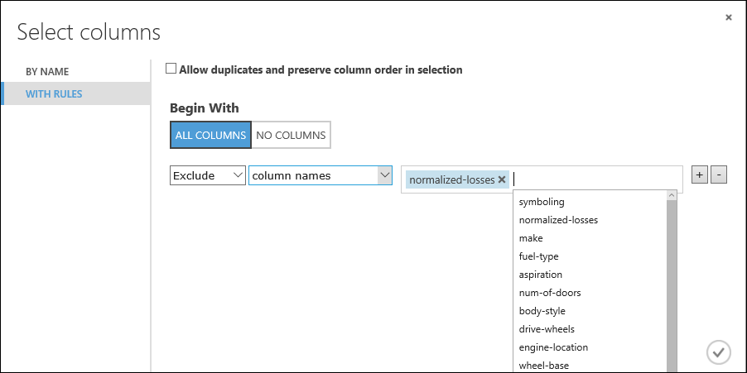

The properties pane for **Select Columns in Dataset** indicates that it will pass through all columns from the dataset except **normalized-losses**.

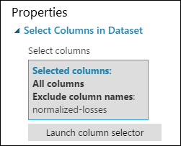

##### **Tip:**

You can add a comment to a module by double-clicking the module and entering text. This can help you see at a glance what the module is doing in your experiment. In this case, double-click the [Select Columns in Dataset](https://msdn.microsoft.com/library/azure/1ec722fa-b623-4e26-a44e-a50c6d726223/) module and type the comment "Exclude normalized-losses."

1. Drag the [Clean Missing Data](https://msdn.microsoft.com/library/azure/d2c5ca2f-7323-41a3-9b7e-da917c99f0c4/) module to the experiment canvas and connect it to the [Select Columns in Dataset](https://msdn.microsoft.com/library/azure/1ec722fa-b623-4e26-a44e-a50c6d726223/) module. In the **Properties** pane, select **Remove entire row** under **Cleaning mode** to clean the data by removing rows that have missing values. Double-click the module and type the comment "Remove missing value rows."

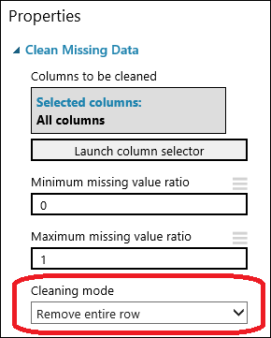

1. Run the experiment by clicking **RUN** under the experiment canvas.

When the experiment is finished, all the modules have a green check mark to indicate that they finished successfully. Notice also the **Finished running** status in the upper-right corner.

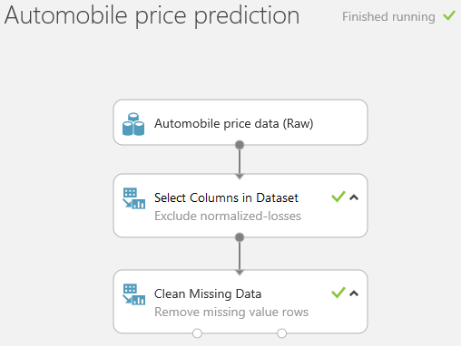

All we have done in the experiment to this point is clean the data. If you want to view the cleaned dataset, click the left output port of the [Clean Missing Data](https://msdn.microsoft.com/library/azure/d2c5ca2f-7323-41a3-9b7e-da917c99f0c4/) module ("Cleaned dataset") and select **Visualize**. Notice that the **normalized-losses** column is no longer included, and there are no missing values.

Now that the data is clean, we're ready to specify what features we're going to use in the predictive model.

## **Step 3: Define features**

In machine learning, features are individual measurable properties of something you’re interested in. In our dataset, each row represents one automobile, and each column is a feature of that automobile.

Finding a good set of features for creating a predictive model requires experimentation and knowledge about the problem you want to solve. Some features are better for predicting the target than others. Also, some features have a strong correlation with other features (for example, city-mpg versus highway-mpg), so they will not add much new information to the model, and they can be removed.

Let's build a model that uses a subset of the features in our dataset. You can come back and select different features, run the experiment again, and see if you get better results. But to start, let's try the following features:

Copy

make, body-style, wheel-base, engine-size, horsepower, peak-rpm, highway-mpg, price

1. Drag another [Select Columns in Dataset](https://msdn.microsoft.com/library/azure/1ec722fa-b623-4e26-a44e-a50c6d726223/) module to the experiment canvas and connect it to the left output port of the [Clean Missing Data](https://msdn.microsoft.com/library/azure/d2c5ca2f-7323-41a3-9b7e-da917c99f0c4/) module. Double-click the module and type "Select features for prediction."
2. Click **Launch column selector** in the **Properties** pane.
3. Click **With rules**.
4. Under **Begin With** click **No columns**, and then select **Include** and **column names** in the filter row. Enter our list of column names. This directs the module to pass through only columns that we specify.

##### **Tip:**

By running the experiment, we've ensured that the column definitions for our data pass from the dataset through the [Clean Missing Data](https://msdn.microsoft.com/library/azure/d2c5ca2f-7323-41a3-9b7e-da917c99f0c4/) module. This means other modules you connect will also have information from the data set.

1. Click the check mark (OK) button.

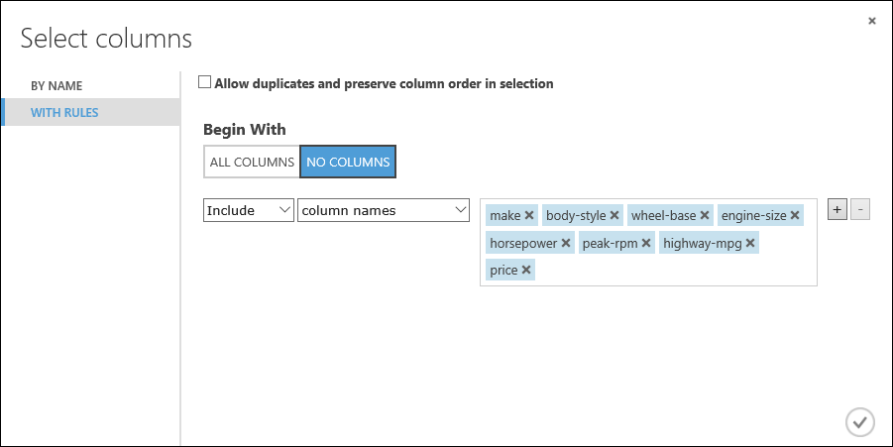

This produces the dataset that will be used in the learning algorithm in the next steps. Later, you can return and try again with a different selection of features.

## **Step 4: Choose and apply a learning algorithm**

Now that the data is ready, constructing a predictive model consists of training and testing. We'll use our data to train the model and then test the model to see how close it's able to predict prices. For now, don't worry about why we need to train and then test a model.

Classification and regression are two types of supervised machine learning techniques. Classification predicts an answer from a defined set of categories, such as a color (red, blue, or green). Regression is used to predict a number.

Because we want to predict price, which is a number, we'll use a regression model. For this example, we'll train a simple linear regression model, and in the next step, we'll test it.

1. We use our data for both training and testing by splitting it into separate training and testing sets. Select and drag the [Split Data](https://msdn.microsoft.com/library/azure/70530644-c97a-4ab6-85f7-88bf30a8be5f/) module to the experiment canvas and connect it to the output of the last [Select Columns in Dataset](https://msdn.microsoft.com/library/azure/1ec722fa-b623-4e26-a44e-a50c6d726223/) module. Set **Fraction of rows in the first output dataset** to 0.75. This way, we'll use 75 percent of the data to train the model, and hold back 25 percent for testing.

##### **Tip:**

By changing the **Random seed** parameter, you can produce different random samples for training and testing. This parameter controls the seeding of the pseudo-random number generator.

1. Run the experiment. This allows the [Select Columns in Dataset](https://msdn.microsoft.com/library/azure/1ec722fa-b623-4e26-a44e-a50c6d726223/) and [Split Data](https://msdn.microsoft.com/library/azure/70530644-c97a-4ab6-85f7-88bf30a8be5f/) modules to pass column definitions to the modules we'll be adding next.
2. To select the learning algorithm, expand the **Machine Learning** category in the module palette to the left of the canvas, and then expand **Initialize Model**. This displays several categories of modules that can be used to initialize machine learning algorithms.

For this experiment, select the [Linear Regression](https://msdn.microsoft.com/library/azure/31960a6f-789b-4cf7-88d6-2e1152c0bd1a/) module under the **Regression** category (you can also find the module by typing "linear regression" in the palette Search box), and drag it to the experiment canvas.

1. Find and drag the [Train Model](https://msdn.microsoft.com/library/azure/5cc7053e-aa30-450d-96c0-dae4be720977/) module to the experiment canvas. Connect the left input port to the output of the [Linear Regression](https://msdn.microsoft.com/library/azure/31960a6f-789b-4cf7-88d6-2e1152c0bd1a/) module. Connect the right input port to the training data output (left port) of the [Split Data](https://msdn.microsoft.com/library/azure/70530644-c97a-4ab6-85f7-88bf30a8be5f/) module.
2. Select the [Train Model](https://msdn.microsoft.com/library/azure/5cc7053e-aa30-450d-96c0-dae4be720977/) module, click **Launch column selector** in the **Properties** pane, and then select the **price** column. This is the value that our model is going to predict.

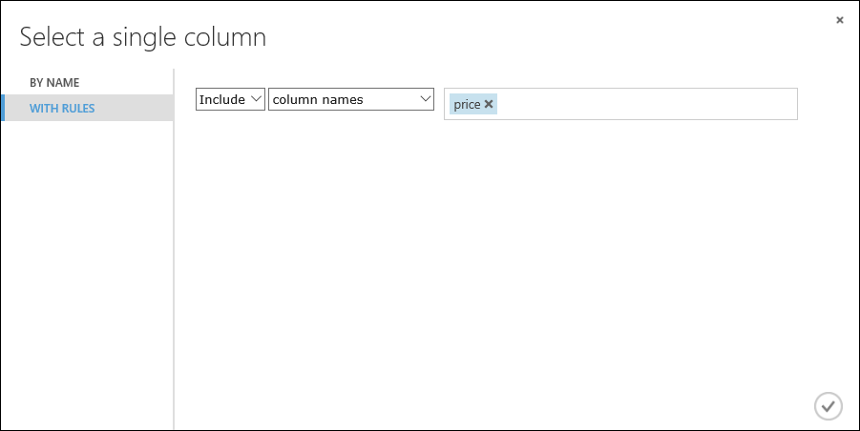

1. Run the experiment.

The result is a trained regression model that can be used to score new samples to make predictions.

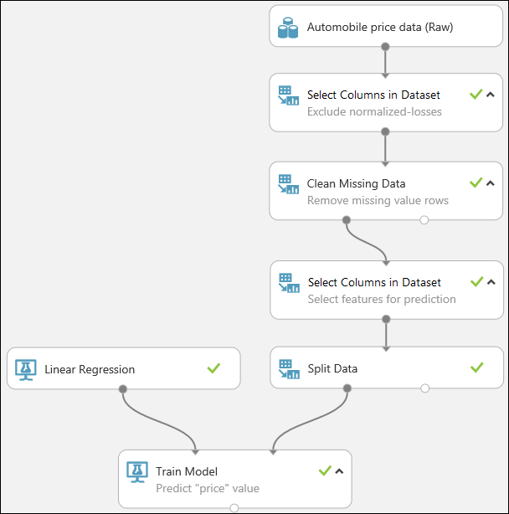

## **Step 5: Predict new automobile prices**

Now that we've trained the model using 75 percent of our data, we can use it to score the other 25 percent of the data to see how well our model functions.

1. Find and drag the [Score Model](https://msdn.microsoft.com/library/azure/401b4f92-e724-4d5a-be81-d5b0ff9bdb33/) module to the experiment canvas and connect the left input port to the output of the [Train Model](https://msdn.microsoft.com/library/azure/5cc7053e-aa30-450d-96c0-dae4be720977/) module. Connect the right input port to the test data output (right port) of the [Split Data](https://msdn.microsoft.com/library/azure/70530644-c97a-4ab6-85f7-88bf30a8be5f/) module.

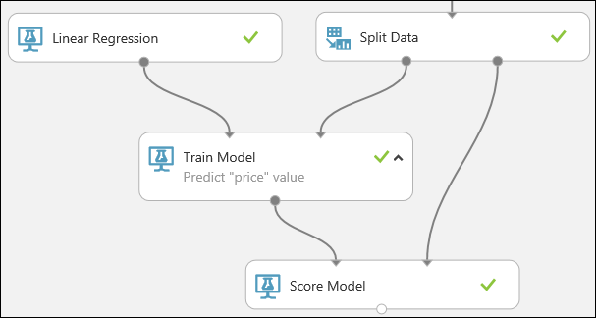

1. To run the experiment and view the output from the [Score Model](https://msdn.microsoft.com/library/azure/401b4f92-e724-4d5a-be81-d5b0ff9bdb33/) module, click the output port, and then select **Visualize**. The output shows the predicted values for price and the known values from the test data.
2. Finally, to test the quality of the results, select and drag the [Evaluate Model](https://msdn.microsoft.com/library/azure/927d65ac-3b50-4694-9903-20f6c1672089/) module to the experiment canvas, and connect the left input port to the output of the [Score Model](https://msdn.microsoft.com/library/azure/401b4f92-e724-4d5a-be81-d5b0ff9bdb33/) module. (There are two input ports because the [Evaluate Model](https://msdn.microsoft.com/library/azure/927d65ac-3b50-4694-9903-20f6c1672089/) module can be used to compare two models.)
3. Run the experiment.

To view the output from the [Evaluate Model](https://msdn.microsoft.com/library/azure/927d65ac-3b50-4694-9903-20f6c1672089/) module, click the output port, and then select **Visualize**. The following statistics are shown for our model:

* **Mean Absolute Error** (MAE): The average of absolute errors (an error is the difference between the predicted value and the actual value).
* **Root Mean Squared Error** (RMSE): The square root of the average of squared errors of predictions made on the test dataset.
* **Relative Absolute Error**: The average of absolute errors relative to the absolute difference between actual values and the average of all actual values.
* **Relative Squared Error**: The average of squared errors relative to the squared difference between the actual values and the average of all actual values.
* **Coefficient of Determination**: Also known as the **R squared value**, this is a statistical metric indicating how well a model fits the data.

For each of the error statistics, smaller is better. A smaller value indicates that the predictions more closely match the actual values. For **Coefficient of Determination**, the closer its value is to one (1.0), the better the predictions.

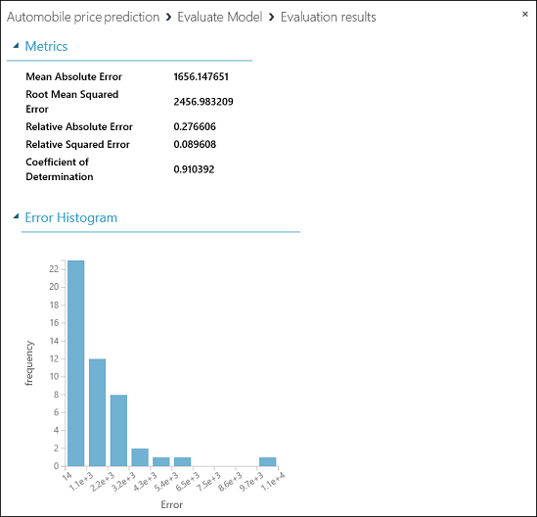

The final experiment should look like this:

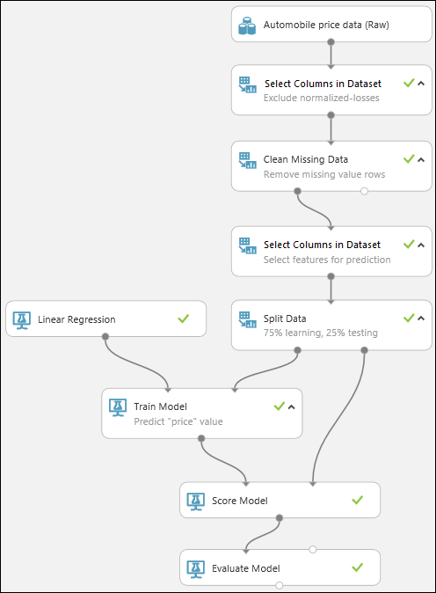

## **Next steps**

Now that you've completed a first machine learning tutorial and have your experiment set up, you can iterate to try to improve the model. For instance, you can change the features you use in your prediction. Or you can modify the properties of the [Linear Regression](https://msdn.microsoft.com/library/azure/31960a6f-789b-4cf7-88d6-2e1152c0bd1a/) algorithm or try a different algorithm altogether. You can even add multiple machine learning algorithms to your experiment at one time and compare two by using the [Evaluate Model](https://msdn.microsoft.com/library/azure/927d65ac-3b50-4694-9903-20f6c1672089/) module.

##### **Tip:**

Use the **SAVE AS** button under the experiment canvas to copy any iteration of your experiment. You can see all the iterations of your experiment by clicking **VIEW RUN HISTORY** under the canvas. See [Manage experiment iterations in Azure Machine Learning Studio](https://azure.microsoft.com/en-in/documentation/articles/machine-learning-manage-experiment-iterations/) for more details.

When you're satisfied with your model, you can deploy it as a web service to be used to predict automobile prices by using new data. See [Deploy an Azure Machine Learning web service](https://azure.microsoft.com/en-in/documentation/articles/machine-learning-publish-a-machine-learning-web-service/) for more details.

For a more extensive and detailed walkthrough of predictive modeling techniques for creating, training, scoring, and deploying a model, see [Develop a predictive solution by using Azure Machine Learning](https://azure.microsoft.com/en-in/documentation/articles/machine-learning-walkthrough-develop-predictive-solution/).